15. This problem involves the Boston data set, which we saw in the lab for this chapter. We will now try to predict per capita crime rate using the other variables in this data set. In other words, per capita crime rate is the response, and the other variables are the predictors.

(a) For each predictor, fit a simple linear regression model to predict the response. Describe your results. In which of the models is there a statistically significant association between the predictor and the response? Create some plots to back up your assertions.

Assuming alpha to be 5%, p-values of all the predictor variables except “chas” are less than 5%. Hence, except for predictor “chas” there is statistically significant relationship between each of the predictor with response variable “crime”.

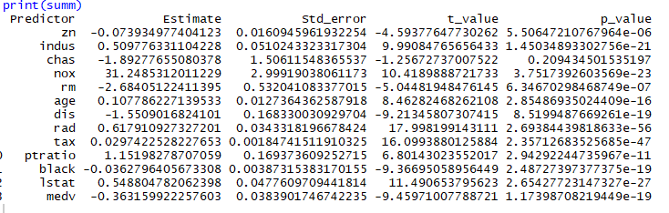

Below is the regression plot for the model which had predictor “chas”

It can be seen from the residual vs fitted plot that there is a non-linear relationship between “chas” and response variable “crim”. The Normal Q-Q plot shows that the residuals are not normally distributed. This makes sense as chas is a qualitative variable.

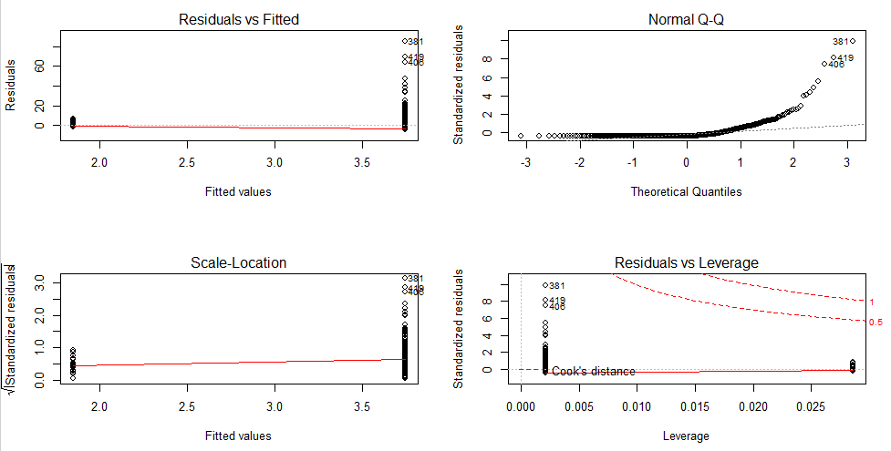

(b) Fit a multiple regression model to predict the response using all of the predictors. Describe your results. For which predictors can we reject the null hypothesis *H*0 : *βj* = 0?

Assuming alpha to be 5%, we can reject the null hypothesis for the predictors whose p-values is less than 5%. Hence, we can reject null hypothesis for: “zn” , “dis”, ”rad”, ”black” and “medv”.

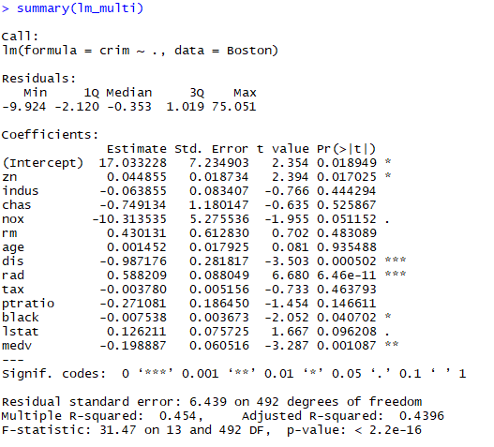

(c) How do your results from (a) compare to your results from (b)? Create a plot displaying the univariate regression coefficients from (a) on the *x*-axis, and the multiple regression coefficients from (b) on the *y*-axis. That is, each predictor is displayed as a single point in the plot. Its coefficient in a simple linear regression

model is shown on the *x*-axis, and its coefficient estimate in the multiple linear regression model is shown on the *y*-axis.

Observations after comparing the results from (a) and (b) are as follows;

* Predictor “chas” is not statistically significant in both results
* Predictors “indus”, ”nox”, ”rm”, “age”, “tax”, “ptratio” and “lstat” are statistically significant for simple linear regression but not for multiple linear regression

This difference is because in the multiple regression the coefficients are correlated and in simple linear regression the response is only dependent on single independent predictor.

Below plot shows each predictor as a single plot;

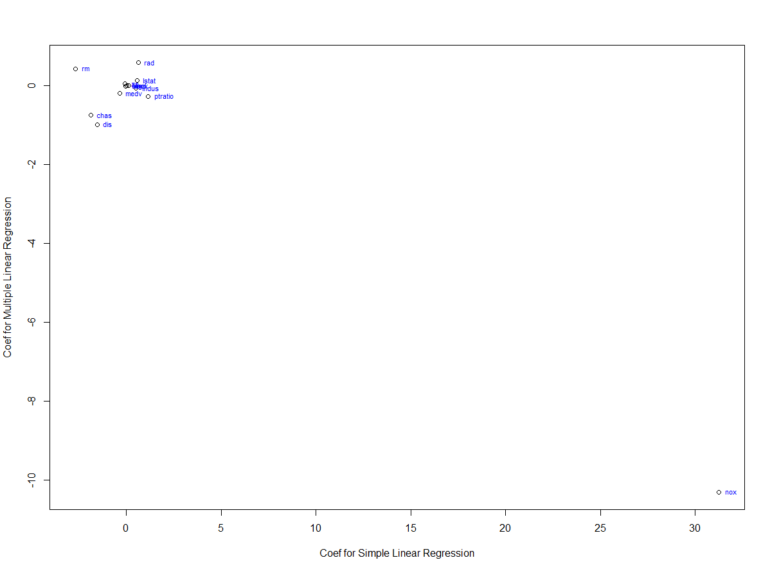

(d) Is there evidence of non-linear association between any of the predictors and the response? To answer this question, for each predictor *X*, fit a model of the form *Y* = *β*0 + *β*1*X* + *β*2*X*2 + *β*3*X*3 + *Ɛ.*

Ans:

Predictors “zn”, “rm”, “rad”, “tax”, “black”, “lstat” have p-values which are not statistically significant but Variables “dis”, ”rad”, ”black” and “medv” have quandratic and cubic coefficients p-values less than 5% (assuming alpha = 5%) and hence are statistically significant which means non-linear effect is visible.

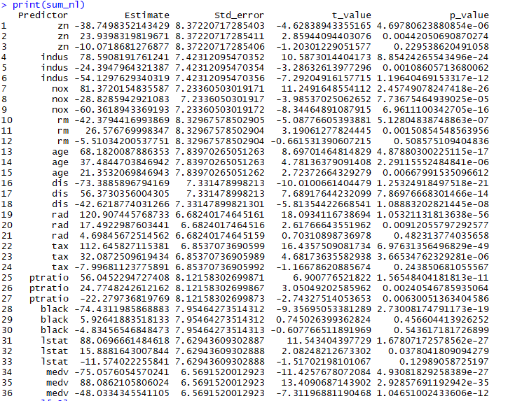

This question should be answered using the Weekly data set, which is part of the ISLR package. This data is similar in nature to the Smarket data from this chapter’s lab, except that it contains 1*,* 089 weekly returns for 21 years, from the beginning of 1990 to the end of 2010.

(a) Produce some numerical and graphical summaries of the Weekly data. Do there appear to be any patterns?

The pairwise correlations between the numeric variables is shown below;

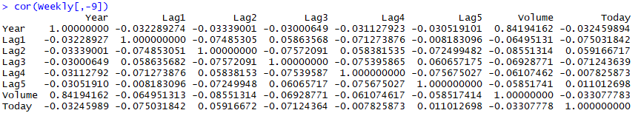

* There is very little correlation between the lag variables i.e previous day’s returns and today’s returns as their values are close to zero.
* The only correlation that we see is between Year and Volume.

Below plot of correlation also shows that volume increases over time;

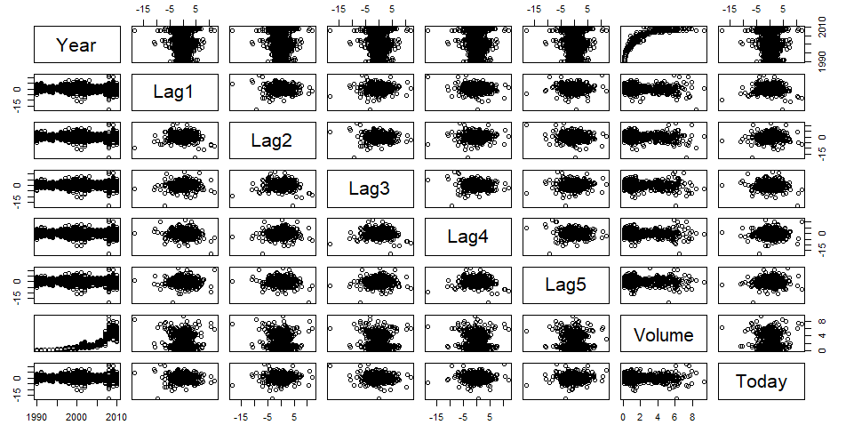

(b) Use the full data set to perform a logistic regression with Direction as the response and the five lag variables plus Volume as predictors. Use the summary function to print the results. Do any of the predictors appear to be statistically significant? If so, which ones?

Summary of the logistic function is given below;

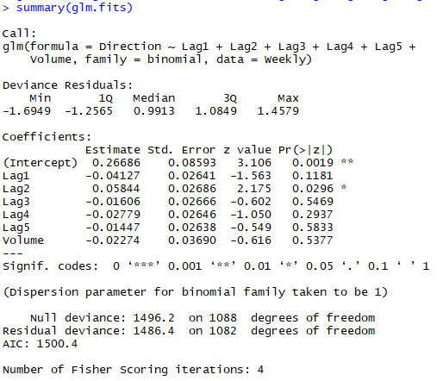

Only Predictor “Lag2” appears to be statistically significant.

(c) Compute the confusion matrix and overall fraction of correct predictions. Explain what the confusion matrix is telling you about the types of mistakes made by logistic regression.

Confusion matrix for above logistic regression is given below;

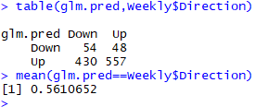

The confusion matrix can tell us how many values are correctly and incorrectly predicted. The diagonal elements in the matrix are the correct predictions i.e. For 54 days the Directions are predicted as “Down” are actually “Down” and for 557 days of Directions which were predicted as “Up” are actually “Up”. The off-diagonal represents the incorrect predictions. We can calculate overall Accuracy and the error rate of the model using confusion matrix.

The overall fraction of correctly predicted = 54+557/1089 = 56.106%

(d) Now fit the logistic regression model using a training data period from 1990 to 2008, with Lag2 as the only predictor. Compute the confusion matrix and the overall fraction of correct predictions for the held out data (that is, the data from 2009 and 2010).

Confusion matrix and the overall fraction of correct predictions for the data from 2009 to 2010 is given below;

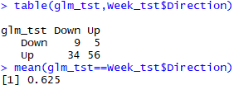

Overall Fraction of correct prediction = 62.5%

(e) Repeat (d) using LDA.

Confusion matrix and the overall fraction of correct predictions using LDA for the data from 2009 to 2010 is given below;

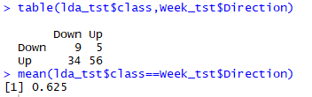

Overall Fraction of correct prediction = 62.5%

(f) Repeat (d) using QDA.

Confusion matrix and the overall fraction of correct predictions using QDA for the data from 2009 to 2010 is given below;

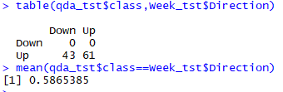

Overall Fraction of correct prediction = 58.65%

Even though the error rate is 41.35%, the model is not performing well as it is classifying all of the data to be “Up”.

(g) Repeat (d) using KNN with *K* = 1.

Confusion matrix and the overall fraction of correct predictions using K-n-n for the data from 2009 to 2010 is given below;

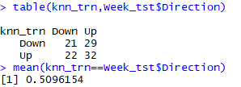

Overall Fraction of correct prediction = 50.9%

Even though the overall Accuracy is less than other models, unlike other models it can identify approximately 49% of “Down” directions i.e. True negatives correctly

(h) Which of these methods appears to provide the best results on this data?

By comparing the above model LDA and Logistic Regression would give better results as have performed well on the test data compared to others.

(i) Experiment with different combinations of predictors, including possible transformations and interactions, for each of the methods. Report the variables, method, and associated confusion matrix that appears to provide the best results on the held out data. Note that you should also experiment with values for *K* in the KNN classifier.

Ans:

Different combinations of predictors and methods were tried and below are the results of their confusion matrix and overall fraction of correct predictions;

1. Logistic regression
2. Variables: Lag1 and Lag 2

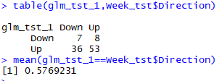

1. Variables: Lag2 and Lag 5

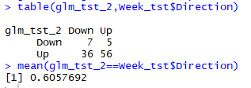

1. Variables: Lag1, Lag2, Lag3 and Lag4

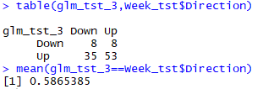

1. LDA
2. Variables: Lag2 and Lag 5

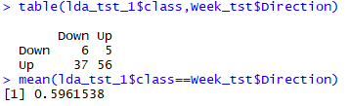

1. Variables: Lag1, Lag2, Lag3 and Volume

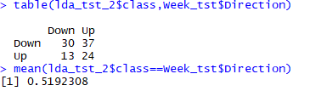

1. Variables: Lag1, Lag2, Lag3 and Volume

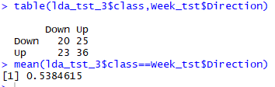

1. QDA
2. Variables: Lag1, Lag2 and Volume

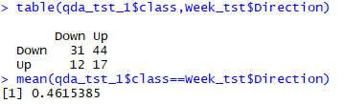

1. Variables: Lag1, Lag2, Lag3, Lag4 and Lag5

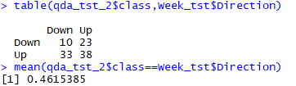

1. Variables: Lag2 and Lag5

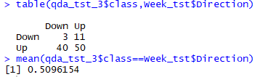

1. KNN
2. Variables: Lag2, Lag3 and Lag4; K= 3

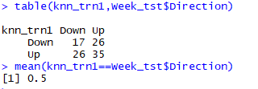

1. Variables: Lag2, Lag4 and Volume; K= 5

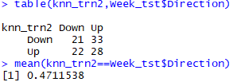

1. Variables: Lag1 and Lag5; K= 4

